9:15 am Welcome and Introductions

9:20–10:45 am Environmental Updates
    - ACCME Update from Kate Regnier
    - ABMS & Continuing Board Certification Commission Update from Tom Granatir
    - Meeting Updates
      - ABMS Conference & discussion around COI and journals. Suzanne Ziemnik and Damon Marquis to help lead this discussion
https://www.nytimes.com/2018/09/13/health/jose-baselga-cancer-memorial-sloan-kettering.html?smprod=nytcore-ipad&smid=nytcore-ipad-share
      - AMA meeting on October 9th focusing on the Impact of Open Payments Reporting on CME Activities – Anne Grupe to provide update
      - PCPI Fall Conference – Quality Payment Program – did anyone attend and can provide an update?
  - Final Items
    - AAMC would like to update the group on the Convey system. Should we invite for Spring meeting?
    - Updated to Moore’s Outcome Model

11:00 am–12:00 pm CMSS Strategic Planning
    - Standardization and infrastructure support of all CG from CMSS
    - Proposed Goal for Component Groups
CMSS component groups provide a vehicle for collaboration across member societies through peer-to-peer interactions, shared learning, and collective action.
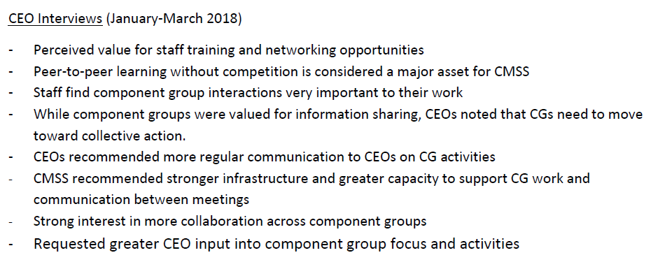
- CPD Component Group Description – Is this still accurate?
Provides an opportunity to network, exchange ideas and share concerns on key issues related to CPD and serve as a recognized forum for the CME/CE directors to voice their positions and concerns on issues impacting the delivery and conduct of CME and CE.

- CPD Component Group Goals? Should we be proactive to determine our future?

1:00– 2:30 pm Strategic Planning – Looking Ahead for Medical Education
  - Feedback from CMSS Summit on the Future of Physician Learning and Improvement
  - Discussion about the delivery of content across transitions and the full continuum from medical education into practice, what are we all doing to address the changes to how medical students are currently access content?

