Survey Summary: Advertisement on Websites and Emails – CMSS
RESPONDENTS: 11 of 11
Closed 6/2/16

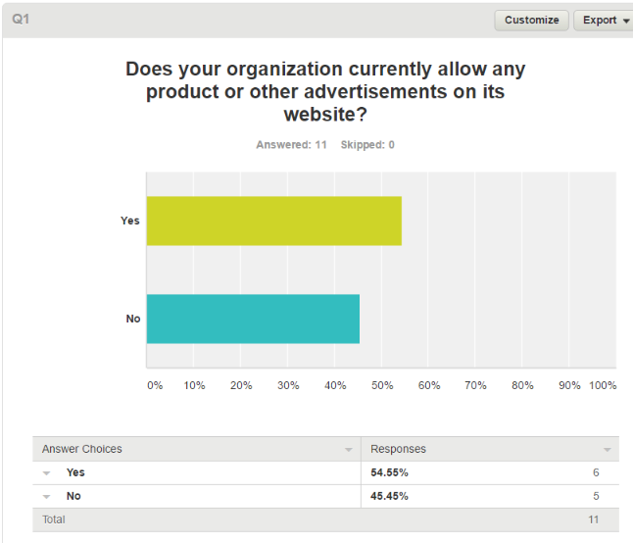

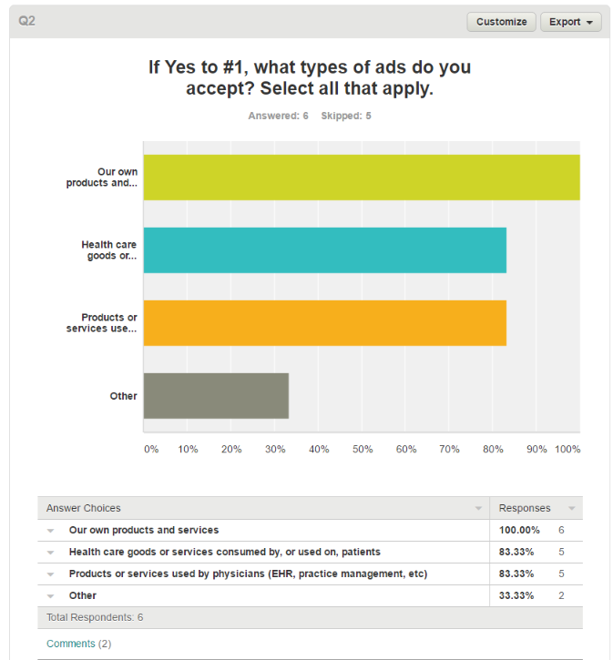
- Hospitals/Academic Centers
- Considering allowing others as listed; would be very interested in what you learn with this survey

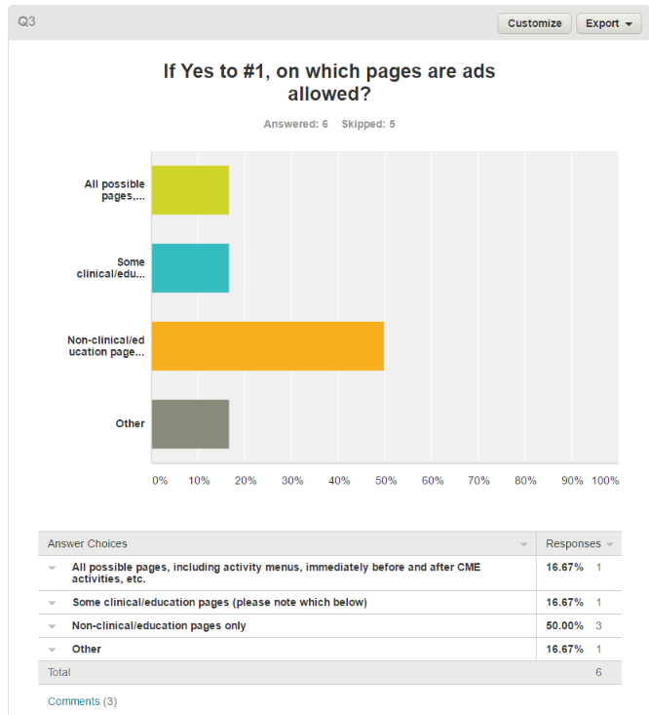
- We have multiple websites. Ads are not allowed on core education sites but are allowed on publication (journal and newsletter) sites.
- House ads do appear on CME pages. Product/device/services appear on other pages.
- Ads are allowed on all "main" pages. Based on the SCS, activity descriptions are not CME content, so ads on those pages are allowed. We do NOT allow ads on any pages where "content" is....

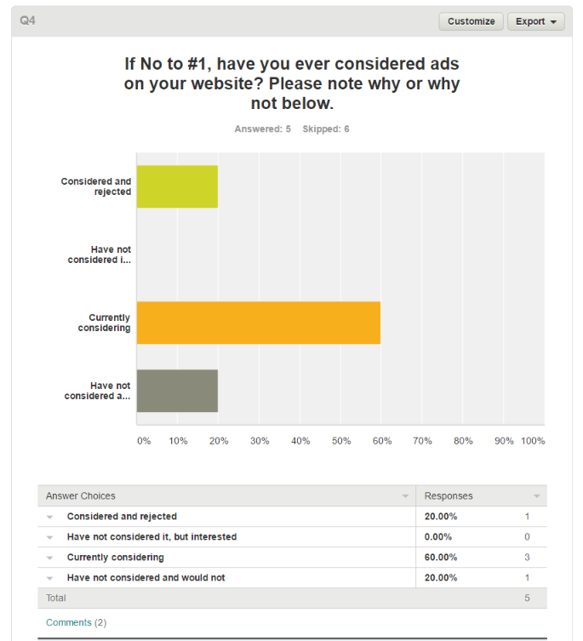
- only promotion is in newsletter and journal
- We have a strict policy of not endorsing products or services; there were concerns that this could be perceived as endorsement in addition to the COI concerns.

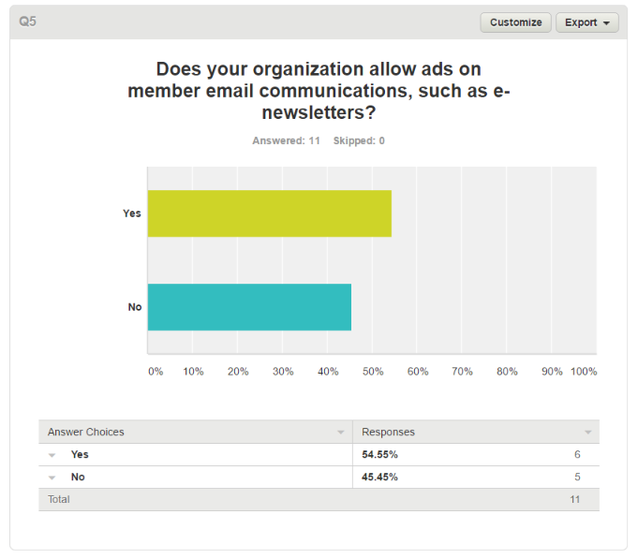
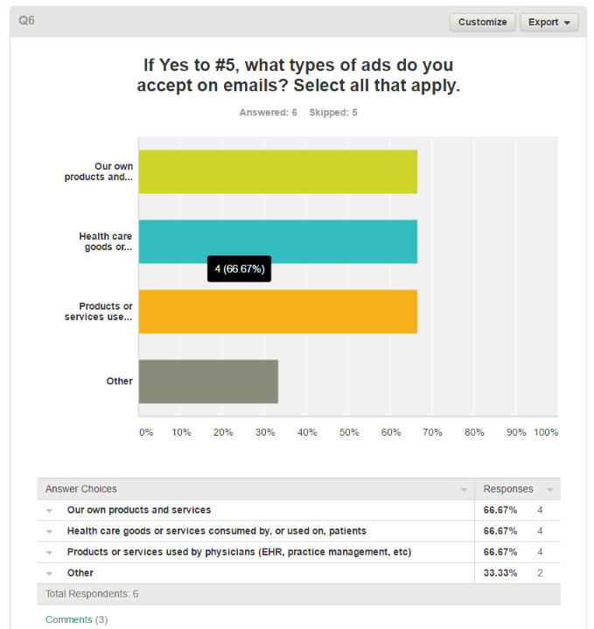
- Hospitals/Academic Centers
- These are basically on our trade publication emails only.
- e-newsletters are published by SmartBriefs; any advertiser can pay for an add.

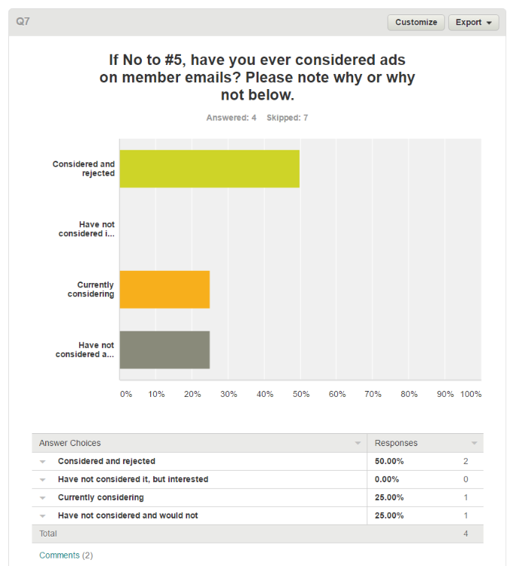
- Same concerns as with ads on website. We do allow ads in our quarterly print member magazine.
- Previously rejected as we didn't have a staff person who could properly manage it. We added a position recently where this could like, so it may be reconsidered in the coming months. We are overdue for a website revamp and might defer the ad discussion until that has occurred so as not to have procedures that will likely change with a new site.

Q8

If you do allow ads on the website and/or on emails, how many ads do you typically sell per year?
- Answered: 7
- Skipped: 4

- 25
- 25+
- This lies outside of the Education Department but we could provide more information if requested if allowed by our colleagues in Publishing and Communications
- managed by digital publications dept
- This is not a huge revenue driver. It's typically bundled in as a part of adveristing for our journal and trade publication to ensure we have enough value on that end. Advertising in our larger healthcare space is down 30-50% YOY, so we try to be flexible with our approach.
- I don't know. This is handled by the marketing department. We just started doing this less than one year ago, but my understanding is it has been a good source of revenue.
- less than 10

Q9

Organization Name / Additional Comments
- Answered: 10
- Skipped: 1

- ASCP
- American Academy of Otolaryngology-Head and Neck Surgery
- American Society of Hematology
- ASCO
- American Society of Plastic Surgeons
- Am. College of Radiology
- American College of Medical Genetics and Genomics
- Steve Folstein, AAAAI
- American Academy of Hospice and Palliative Medicine Julie Bruno
- American College of Occupational and Environmental Medicine (ACOEM)

